Procvičování probraného učiva

Answer the questions. Use short answers:
Odpověz na otázky. Použij krátké odpovědi:

Yes, I can. No, it isn’t. No, I can’t. Yes, I do.
Yes, it is. No, I don’t.

1. Can you play snakes and ladders? _____________________
2. Can you play ludo? |  | _____________________
3. Do you like pizzas? |  | _____________________
4. Do you like mushrooms? |  | _____________________
- Is it a car? 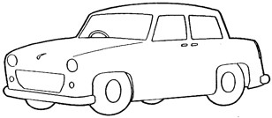  - Is it number eight? 3  - Is it a doll? 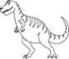  - Can you play the maracas?  - Can you play the piano?  - Do you like chocolate?  - Is it an orange?                 

